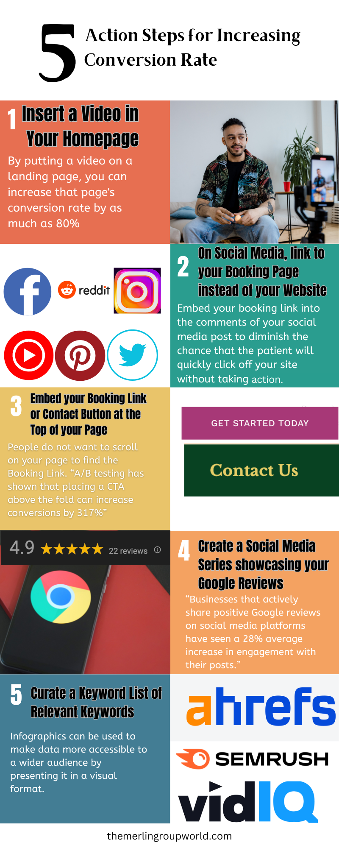

* Optimize your website to make it easy for the user to book with you.
* Embed relevant Keywords into your Website
  + If you are a local business, add your city at the end of your keywords
* Make sure to write a meta description in the website that has 140-160 characters maximum.
* Embed Google Tag Manager, Google Search Console & Google Analytics into your site for real-time analytics
* Optimize your site for topics > keywords
* Create educational content, make your blogs around the keywords and embed videos into the blogs
  + Embed relevant keywords into the website

***Instagram Keywords:***

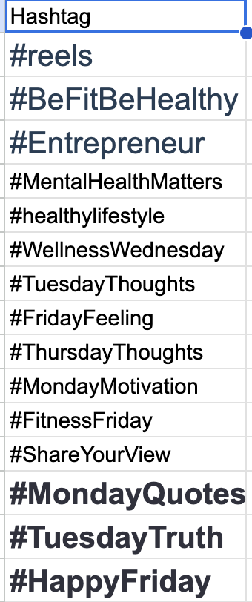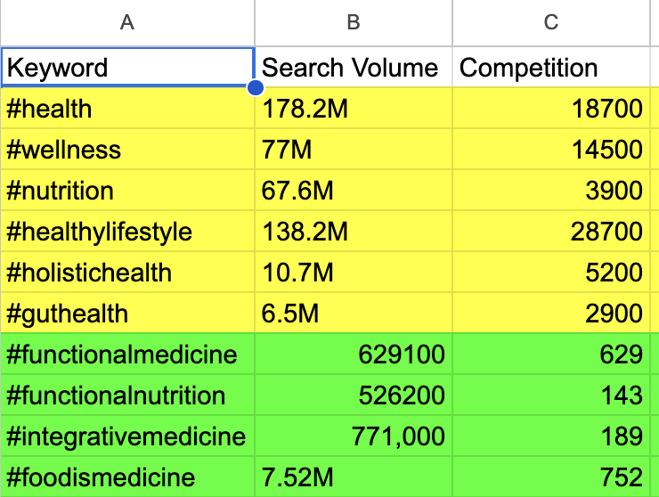

*Social Media best practices by Modality:*

| Health Coaches | Acupuncture | Chiropractic |
| --- | --- | --- |
| Use YouTube or LinkedIn groups | Instagram or Facebook | Facebook, YouTube, Instagram |

| Nutrition | Stem Cell Therapy | Hypnotherapy | Dieticians or Ayurveda |
| --- | --- | --- | --- |
| YouTube, Instagram | YouTube, Facebook | TikTok, YouTube, Instagram | YouTube or Instagram |

| Chelation/Naturopathy | Homeopathy | Alternative Practitioners |
| --- | --- | --- |
| YouTube or Instagram | LinkedIn, YouTube, Instagram, TikTok | X, YouTube |

***Keywords to Use***

**YouTube Health Coaches**

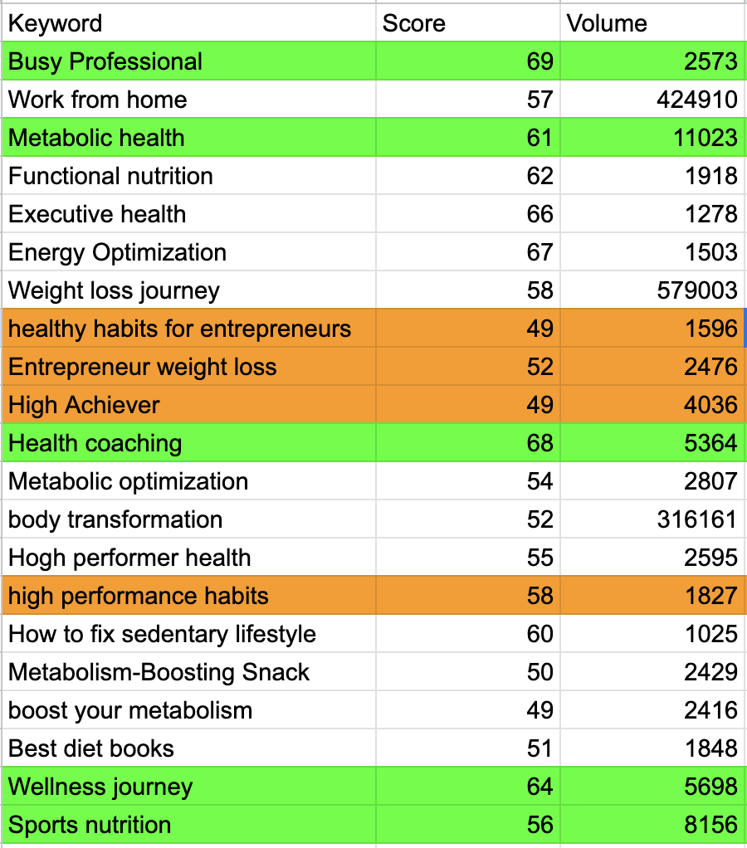

Acupuncture (Website)

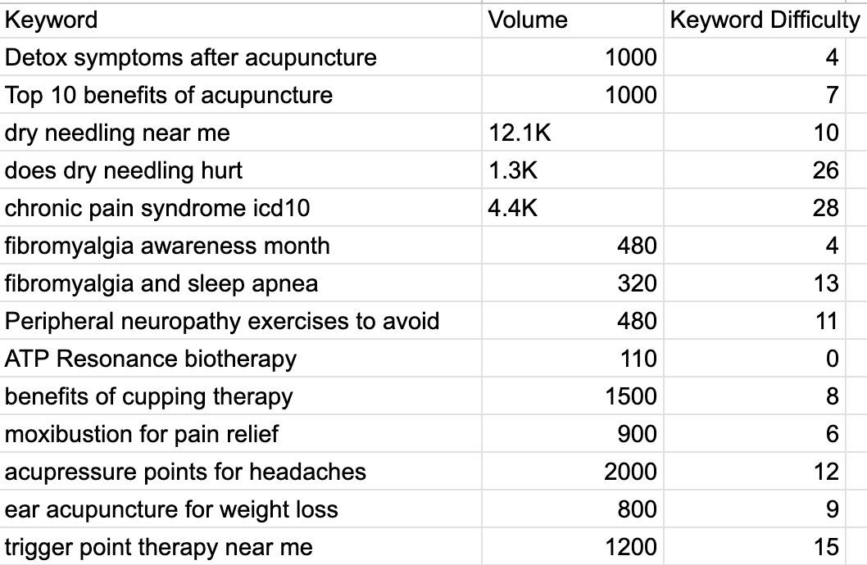

**Nutrition (YouTube & Website)**

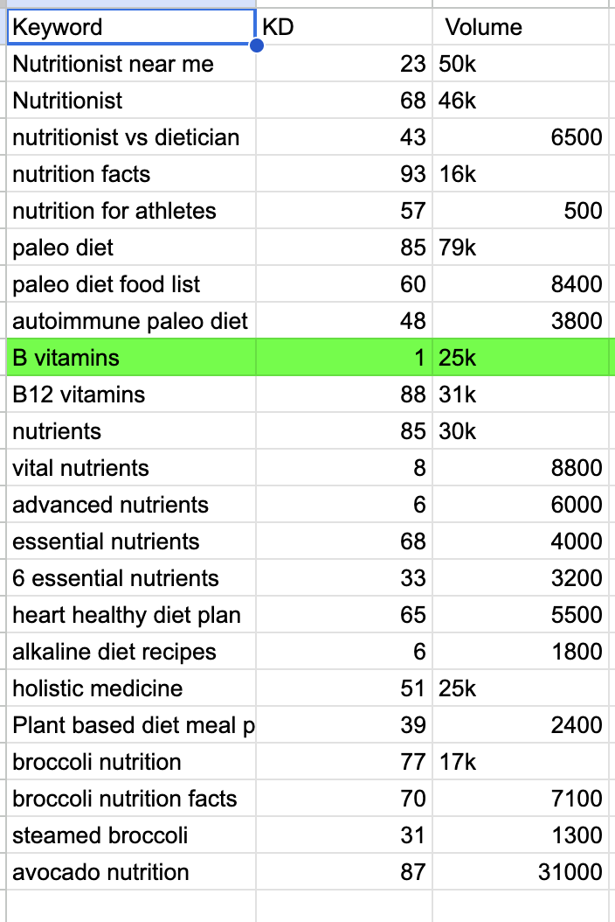

**Chiropractic Website (For New Jersey, replace it with your area)**

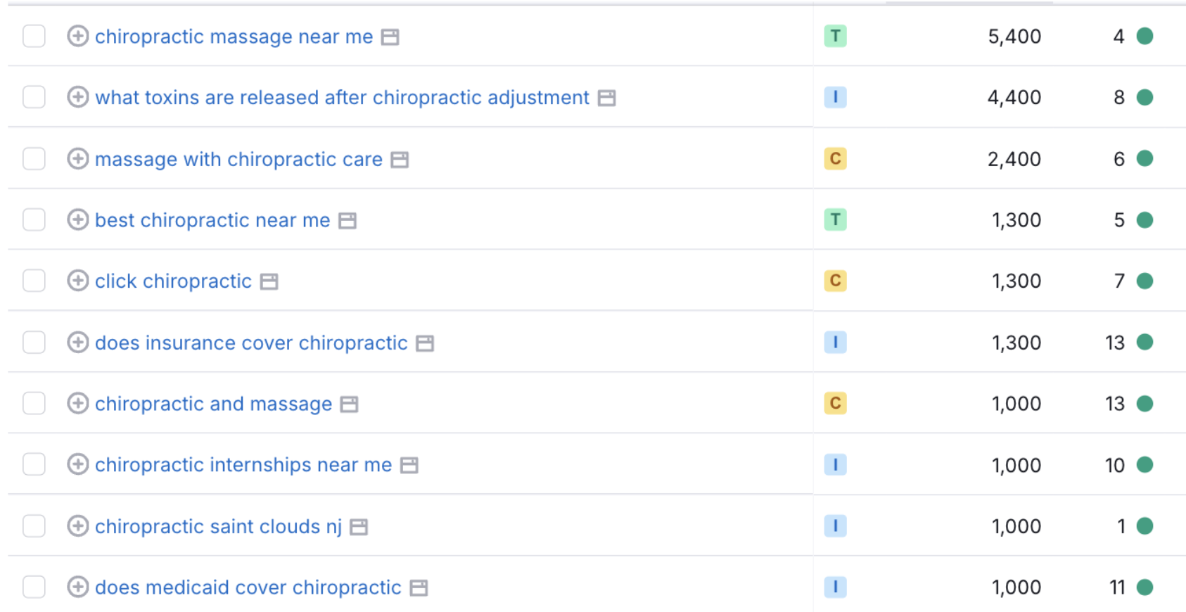



**Hypnotherapy Social Media or Website**

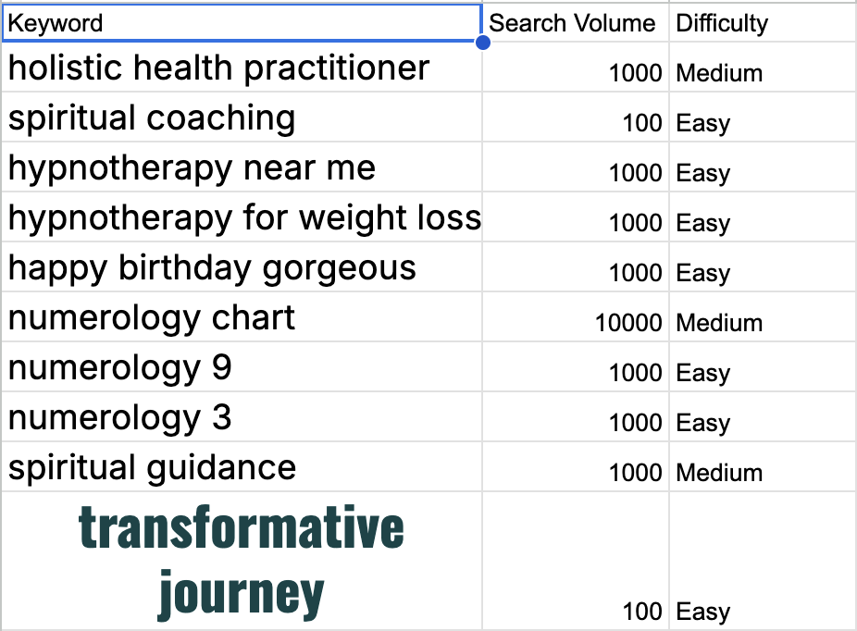

**Holistic/Alternative Practitioners Website**

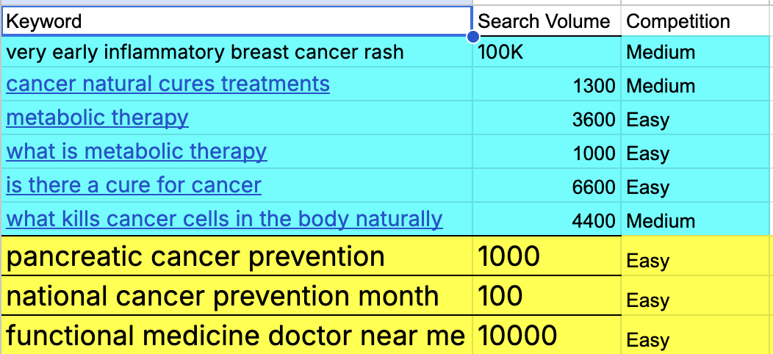

**Homeopathy, Chelation, Naturopathy, Stem Cell Therapy, Herbal Medicine Web Keywords**

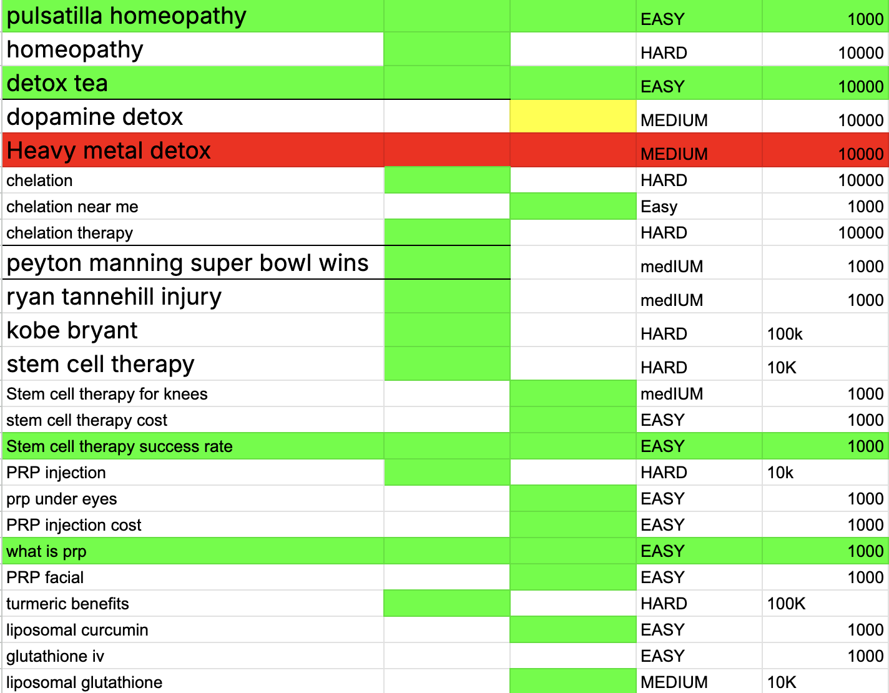

**Ayurveda Website Keywords**



**Dietician Website/YouTube Keywords**

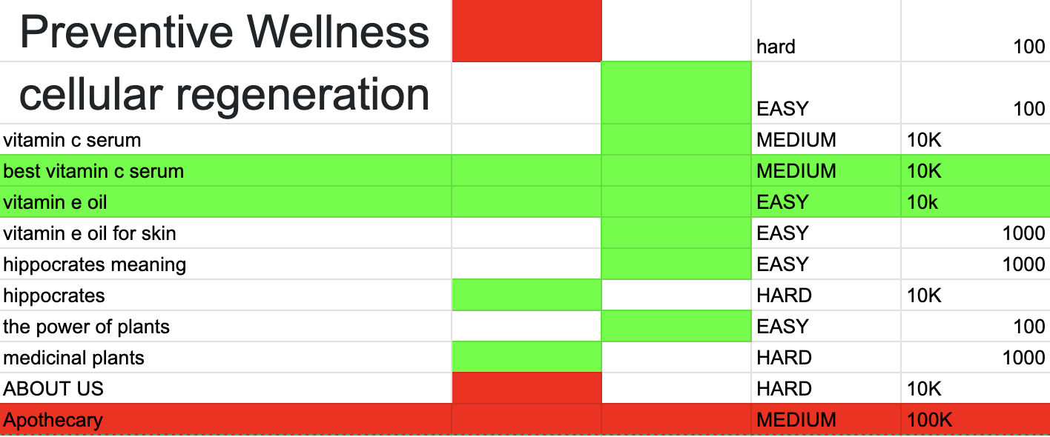

***Social Media Best Practices***

* Use 3-5 MAX Hashtags on platforms
* Use 1-2 general hashtags like #holistichealth and #[your modality] then the other hashtags should be about the video
* Tell the audience what the video will be about in the first 8 seconds
* Embed VidIQ into your YouTube channel
* Use your analytics on each platform to make decisions
* Put your website booking page in the first line of the description so it is easily seen, also add it to the comments
* Use this strategy:
  + Educate
  + CTA: “Watch to the end”, “Comment below”, etc
  + CTA: “Book a consultation, link in the comments”, “Call today, Number in the Bio (or take them to your website with the phone number first thing they see)
* Your email marketing should be showcasing value. Make it short and be consistently testing
* DO NOT FOCUS ON VIEWS. Make the same content, your branding should come off that you are your modality and address ____ ailment
  + The algorithm will punish you if you consistently change your content.

Foreword:

Providers join the platform for a personalized plan, and to have our team integrate the plan into their site for them so they can focus on patient acquisition. Visit <https://themerlingroupworld.com/telehealth> for more information.